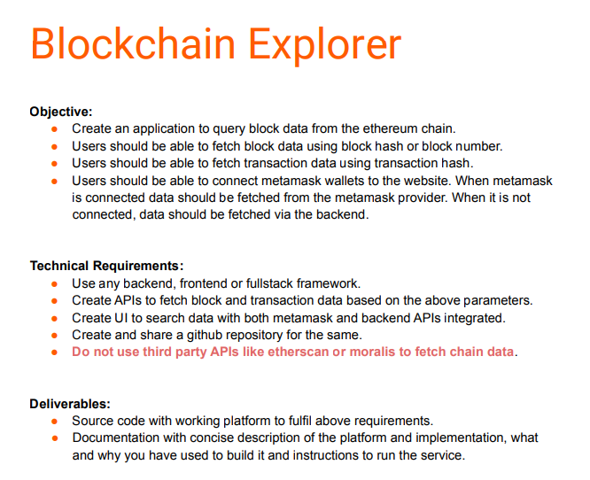

-To Complete the above objectives and the technical requirements we’ve used the
Following tools and their library:
- IDE Used: PyCharm
- Back-end
- Python-Flask
- Web3
- Meta-mask
- Front-end
- Reactjs
- Geth

-Major Points to understand:
1) Web3.py: Web3.py is a Python library for interacting with Ethereum. It’s commonly found in decentralized apps (Dapps) to help with sending transactions, interacting with smart contracts, reading block data, and a variety of other use cases.The original API was derived from the Web3.js Java script API, but has since evolved toward the needs and creature comforts of Python developers.
2) Ethereum Chain: Ethereum is a decentralized blockchain platform that establishes a peer-to-peer network that securely executes and verifies application code, called smart contracts. Smart contracts allow participants to transact with each other without a trusted central authority. There are roughly 120 million Ethereum chains.
3) Block: A block is a place in a blockchain where information is stored and encrypted. Blocks are identified by long numbers that include encrypted transaction information from previous blocks and new transaction information.
4) Block Hash: The block header is the hash returned from generating a Merkle tree that is below the current difficulty target for the blocks data. The block hash is a value containing the hexadecimal data.
5) Transaction: An Ethereum transaction refers to an action initiated by an externally-owned account, in other words an account managed by a human, not a contract. It is just like a transaction from ones account to another.
6) Transaction Hash: A transaction hash/ID (often abbreviated as tx hash or txn hash) is a unique identifier, similar to a receipt, that serves as proof that a transaction was validated and added to the blockchain. It contains data in the hexadecimal format.
7) Metamask: MetaMask is a free web and mobile crypto wallet that allows users to store and swap cryptocurrencies, interact with the Ethereum blockchain ecosystem, and host a growing array of decentralized applications (dApps). It is one of the most widely used crypto applications in the world.
8) Flask: A Web Application Framework or a simply a Web Framework represents a collection of libraries and modules that enable web application developers to write applications without worrying about low-level details such as protocol, thread management, and so on. Flask is a web framework, it’s a Python module that lets you develop web applications easily.
9) Geth: Geth is an Ethereum execution client meaning it handles transactions, deployment and execution of smart contracts and contains an embedded computer known as the Ethereum Virtual Machine. Running Geth alongside a consensus client turns a computer into an Ethereum node.

OBJECTIVE-1:
-To Complete the first objective i.e. to create an application to query block data from the Ethereum chain
We have written thus code to connect to the Ethereum chain:
# Import Essential lib #web3
from web3 import Web3
from web3.middleware import geth_poa_middleware
# Connect to an Ethereum node
# w3 = Web3(Web3.HTTPProvider('https://celo-mainnet.infura.io/v3/c0675c5a775e421db5430b57358c8b52'))
w3 = Web3(Web3.HTTPProvider('https://127.0.0.1:8545’)
w3.middleware_onion.inject(geth_poa_middleware, layer=0)
print(w3)
print(w3.isConnected())
block_number = w3.eth.blockNumber
# Get the block data for the latest block
Block_data = w3.eth.get_block(block_number)
print("Block Number: ", block_number)
# print("Block Hash: ", block['hash'])
print("Block Timestamp: ", block['timestamp'])
print("Block Transactions: ", block['transactions'])
print("Block_data“)

OUTPUT:

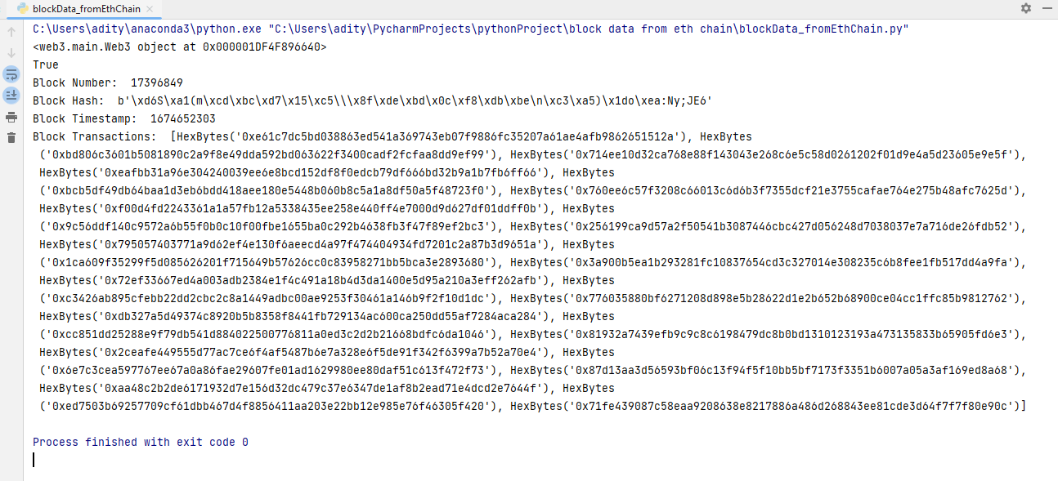

This code connects to the Ethereum mainnet, a service that allows you to access the Ethereum .
You can also use the web3.py library to connect to a local node or a testnet, you can use the following code to connect to a local node.
“w3 = Web3(Web3.HTTPProvider("http://127.0.0.1:8545"))”

OBJECTIVE-2
-To complete the second objective we have written a code snippet to fetch the block data using the block number and the block hash:
from web3 import Web3
from flask import Flask, jsonify
from web3.middleware import geth_poa_middleware
#Getting block data using block number & block Hash
def get_block_data_num(block_number):
# w3 = Web3(Web3.HTTPProvider('https://celo-mainnet.infura.io/v3/c0675c5a775e421db5430b57358c8b52'))
w3 = Web3(Web3.HTTPProvider('https://127.0.0.1:8545’)
Block_data_using_num = w3.eth.get_block(block_number) #Using Block Number
print(Block_data_using_num)
block_number = int(input("Enter Block Number: "))
get_block_data_num(block_number)
print("\\n")
def get_block_data_hash(block_hash):
w3 = Web3(Web3.HTTPProvider('https://celo-mainnet.infura.io/v3/c0675c5a775e421db5430b57358c8b52'))
w3.middleware_onion.inject(geth_poa_middleware, layer=0)
#Hash Valuse: '0x55a2d76a8c181f5ff01efc382aea84a8e886172999459c0f83bd1ba6f57a8d6e'
Block_data_using_hash = w3.eth.get_block(block_hash) #Using Block Hash
print(Block_data_using_hash)
block_hash = input("Enter Block Hash: ")
get_block_data_hash(block_hash)

OUTPUT:
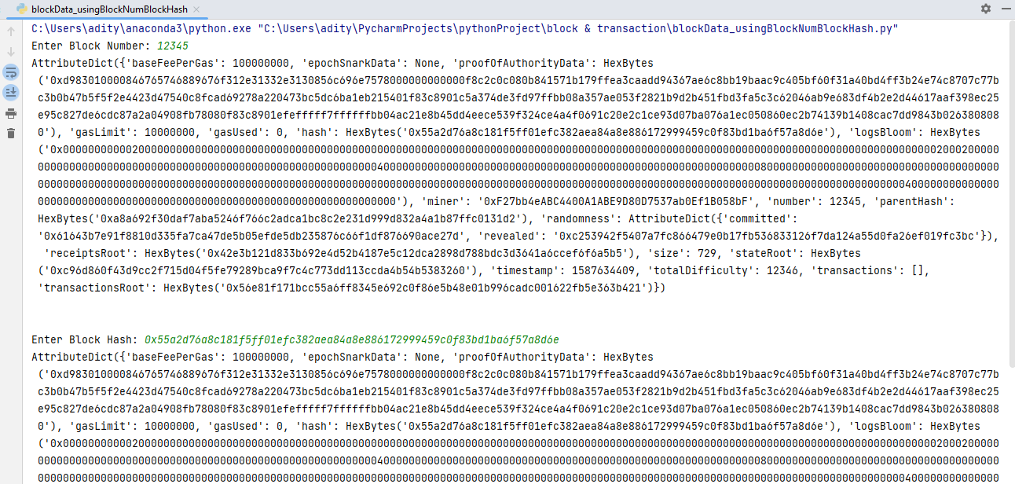

-This code is written in Python using the Flask web framework and the web3.py library to interact with the Ethereum blockchain. It has two functions get_block_data_num() and get_block_data_hash() both functions take different inputs, first one takes block number and second one takes block hash as input.

The get_block_data_num() function takes a block number as an input, and it uses the web3.py library to connect to the Ethereum blockchain using an HTTPProvider. It also uses a middleware to handle the PoA consensus mechanism. Then it uses the w3.eth.get_block() function to query the block data using the block number passed as an argument to the function.

The get_block_data_hash() function takes a block hash as an input, and it also uses the web3.py library to connect to the Ethereum blockchain using an HTTPProvider. It also uses a middleware to handle the PoA consensus mechanism. Then it uses the w3.eth.get_block() function to query the block data using the block hash passed as an argument to the function.

Both functions print the block data retrieved from the blockchain to the console. And it's important to note that the get_block_data_num() function prompts the user to enter a block number, and the get_block_data_hash() function prompts the user to enter a block hash.

OBJECTIVE-3
-To complete the third objective we have written the code to fetch transaction data using transaction hash as below:

OUTPUT:
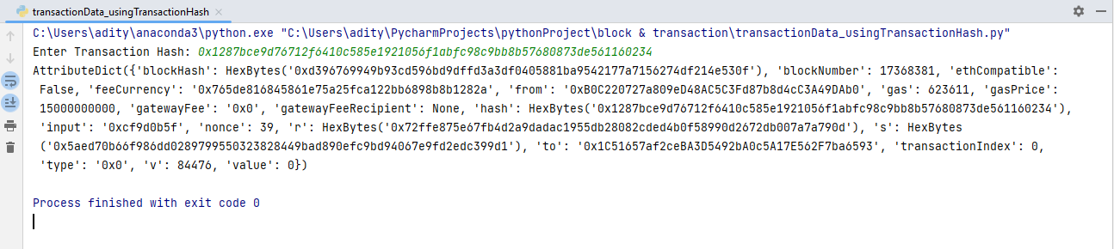
from web3 import Web3
from flask import Flask, jsonify
from flask_cors import CORS
from web3.middleware import geth_poa_middleware
#Getting Transaction data using transaction hash:
#'0x1287bce9d76712f6410c585e1921056f1abfc98c9bb8b57680873de561160234'
def get_transaction_data(transaction_hash):
# w3 = Web3(Web3.HTTPProvider('https://celo-mainnet.infura.io/v3/c0675c5a775e421db5430b57358c8b52'))
w3 = Web3(Web3.HTTPProvider('https://127.0.0.1:8545’)
w3.middleware_onion.inject(geth_poa_middleware, layer=0)
Transaction_data = w3.eth.get_transaction(transaction_hash) #Using Transaction Hash
print(Transaction_data)
transaction_hash = input("Enter Transaction Hash: ")
get_transaction_data((transaction_hash)

OBJECTIVE-4
-To connect metamask wallets to the website we have created an UI and a bacend using the flask.
When metamask is connected data will be fetched from the metamask provider as below code worked:
Metamask.py:
from flask import Flask, render_template
# Flask App
app = Flask(__name__)
@app.route('/')
def index():
return render_template('index.html')

The above code connect the flask application to the html page that we have created to fetch the data from the metamask below:
Index.html:
<html>
<head>
<title>MetaMask Connection Page</title>
</head>
<body>
<center>
<h1>Connect Your MetaMask Wallet Here!</h1>
<button id='connectWallet' onclick="">Connect Wallet</button>
<button id='getBalance' onclick="checkBalance()">Get Balance of Wallet</button>
<p id="walletAddress"></p>
<p id="walletBalance"></p>
<script type="text/javascript">
window.userWalletAddress = null
const connectWallet = document.getElementById('connectWallet')
const walletAddress = document.getElementById('walletAddress')
const walletBalance = document.getElementById('walletBalance')
function checkInstalled() {
if (typeof window.ethereum == 'undefined') {
connectWallet.innerText = 'MetaMask isnt installed, please install it'
connectWallet.classList.remove()
connectWallet.classList.add()
return false
}
connectWallet.addEventListener('click', connectWalletwithMetaMask)
}
async function connectWalletwithMetaMask() {
const accounts = await window.ethereum.request({ method: 'eth_requestAccounts' })
.catch((e) => {
console.error(e.message)
return
})
if (!accounts) { return }
window.userWalletAddress = accounts[0]
walletAddress.innerText = window.userWalletAddress
connectWallet.innerText = 'Sign Out'
connectWallet.removeEventListener('click', connectWalletwithMetaMask)
setTimeout(() => {
connectWallet.addEventListener('click', signOutOfMetaMask)
}, 200)
}
function signOutOfMetaMask() {
window.userwalletAddress = null
walletAddress.innerText = ''
connectWallet.innerText = 'Connect Wallet'
connectWallet.removeEventListener('click', signOutOfMetaMask)
setTimeout(() => {
connectWallet.addEventListener('click', connectWalletwithMetaMask)
}, 200 )
}
async function checkBalance() {
let balance = await window.ethereum.request({ method: "eth_getBalance",
params: [
window.userWalletAddress,
'latest'
]
}).catch((err)=> {
console.log(err)
})
console.log(parseFloat((balance) / Math.pow(10,18)))
walletBalance.innerText = parseFloat((balance) / Math.pow(10,18))
}
window.addEventListener('DOMContentLoaded', () => {
checkInstalled()
})
</script>
</center>
</body>
</html>

-The above code contains the code which collects the present in the metamask wallet and shows the data on that HTML page that we have created.
OUTPUT:

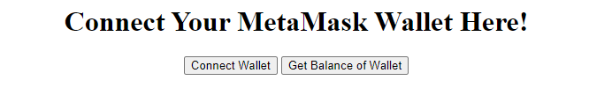

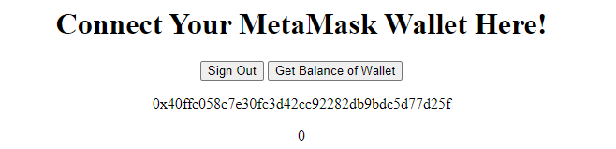

TECHNICAL REQUIREMENTS:
REQUIREMENT -1:
-Use any backend, frontend or full-stack framework.
We have used:
- Python-Flask frame work & web3.py lib for back-end.
- Reactjs for front-end.

REQUIREMENT -2:
-Creating APIs to fetch block and transaction data based on the above parameters:
We have used the Python-Flask framework to create the APIs to fetch Block Data & Transaction data.

OUTPUT:
import json
# from attrdict import AttrDict
from web3 import Web3
from flask import Flask, jsonify
from flask_cors import CORS
from web3.middleware import geth_poa_middleware
app = Flask(__name__)
# CORS(app)
CORS(app, resources={r"/api/*": {"origins": "*"}}, headers='Content-Type')
#Getting block data using block number
@app.route('/api/block/number/<int:block_number>', methods=['GET'])
def fetch_block_data_num(block_number):
try:
# w3 = Web3(Web3.HTTPProvider('https://celo-mainnet.infura.io/v3/c0675c5a775e421db5430b57358c8b52'))
w3 = Web3(Web3.HTTPProvider('https://127.0.0.1:8545’)
w3.middleware_onion.inject(geth_poa_middleware, layer=0)
Block_data = w3.eth.getBlock(block_number)
return json.dumps(Block_data, default=str)
except:
return json.dumps("Please Enter Block Number")
print("\n")
#Getting block data using block Hash
# '0x55a2d76a8c181f5ff01efc382aea84a8e886172999459c0f83bd1ba6f57a8d6e'
@app.route('/api/block/hash/<block_number>', methods=['GET'])
def fetch_block_data_hash(block_number):
try:
# w3 = Web3(Web3.HTTPProvider('https://celo-mainnet.infura.io/v3/c0675c5a775e421db5430b57358c8b52'))
w3 = Web3(Web3.HTTPProvider('https://127.0.0.1:8545’)
w3.middleware_onion.inject(geth_poa_middleware, layer=0)
Block_data = w3.eth.getBlock(block_number)
return json.dumps(Block_data, default=str)
except:
return json.dumps("Please Enter Block Hash")
print("\n")
# Getting Transaction data using transaction hash:
# '0x1287bce9d76712f6410c585e1921056f1abfc98c9bb8b57680873de561160234'
@app.route('/api/block/transaction_hash/<transaction_hash>', methods=['GET'])
def fetch_transaction_data(transaction_hash):
try:
w3 = Web3(Web3.HTTPProvider('https://127.0.0.1:8545’)
# w3 = Web3(Web3.HTTPProvider('https://celo-mainnet.infura.io/v3/c0675c5a775e421db5430b57358c8b52'))

w3.middleware_onion.inject(geth_poa_middleware, layer=0)
Transaction_data = w3.eth.get_transaction(transaction_hash)
return json.dumps(Transaction_data, default=str)
except:
return json.dumps("Please Enter Transaction Hash")
if __name__ == '__main__':
app.run(debug=True, port=5000)

OUTPUT:

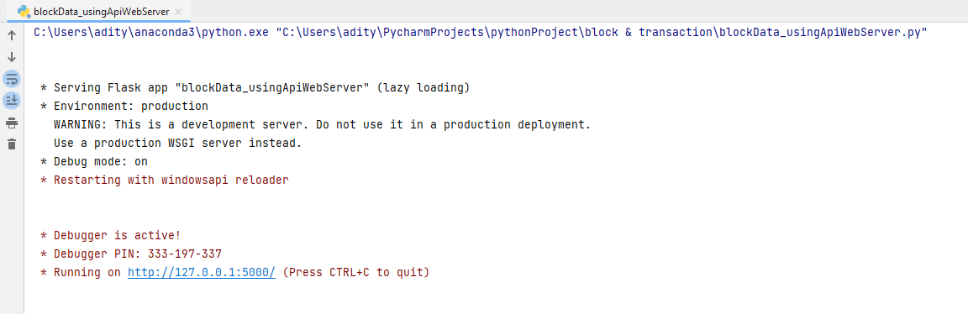

EQUIREMENT -3:
- Created UI to search data with both meta-mask and backend APIs integrated.
We have created the UI using the Reactjs to search the data.

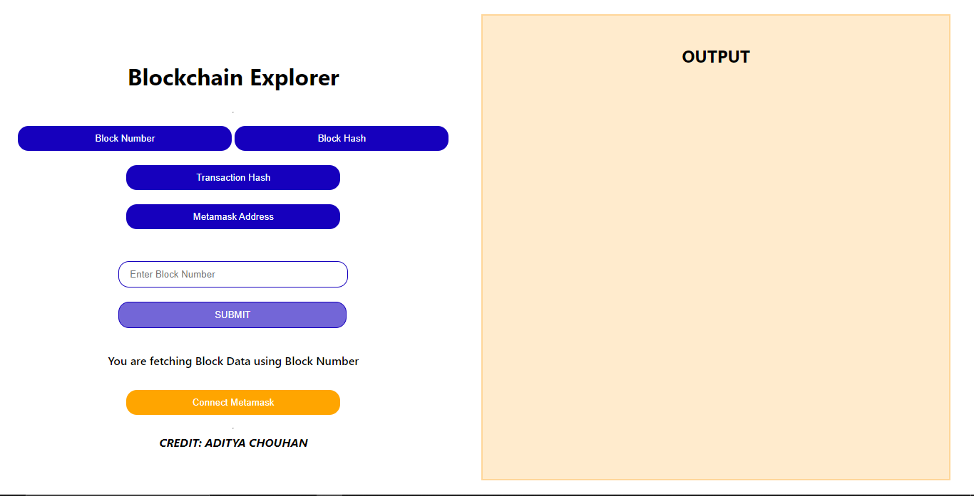

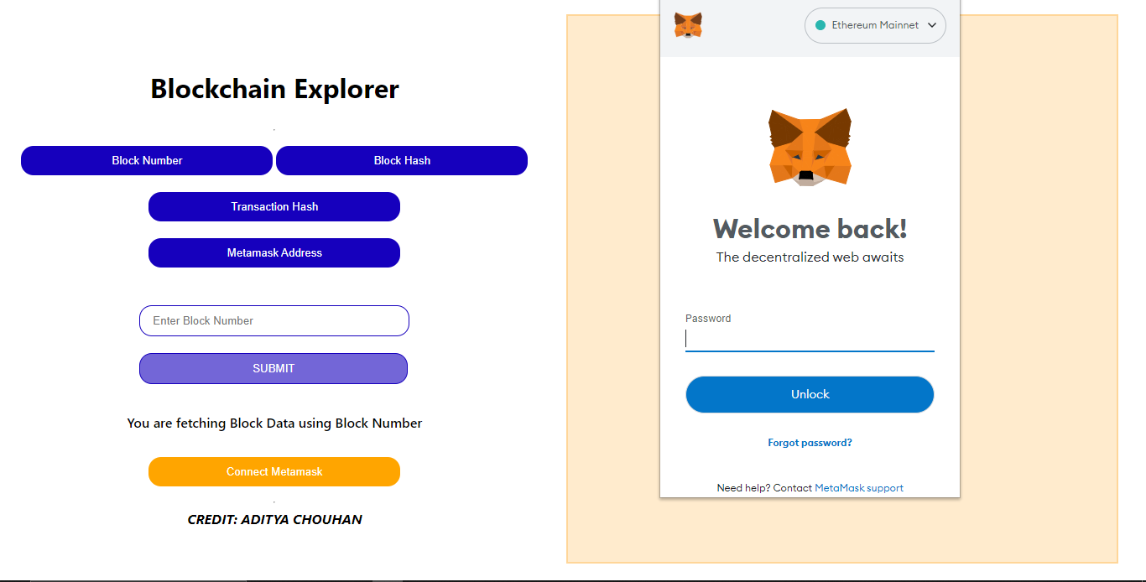

OUTPUT:

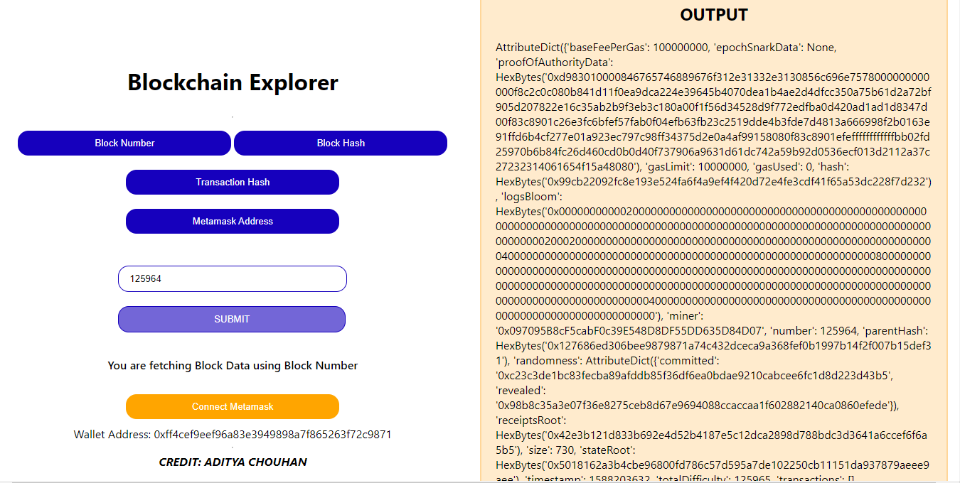

REQUIREMENT -4:
- Created and shared a GitHub repository for the same.
GitHub: https://github.com/error000002/deqode_task
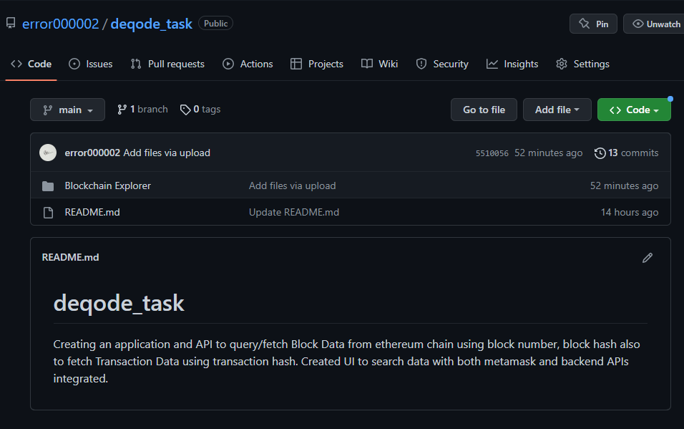

-Aditya Chouhan Date: 27-01-2023
Thank You

